Monolithic PAD
minor change, such as fixing a spelling mistake in the static website, the entire web application archive needs to be rebuilt and redeployed.
Including the possibility of revenue loss if something breaks during deployment.
making involves creating a new branch in the code base, making the correction, building a new artifact, assigning a new version, and deploying it to production.
introduce uncertainties and complexities that demand careful consideration
MAYBE MANUAL CORR FOR MAJOR CHANGES

Architecture rules of thumb
HIGH COHESION( elem of a sw mod belong 2 each other) LOW COUPLING(dependency)
Systems with high cohesion and low coupling would automatically have separation of concerns, and vice versa.

Separation of concerns
advocates breaking a computer program into distinct and independent sections.
creates of more scalable, modular, and maintainable software systems.
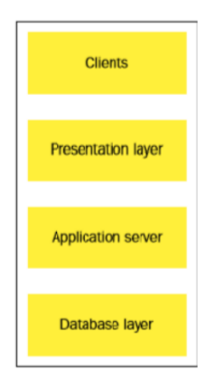
3tier
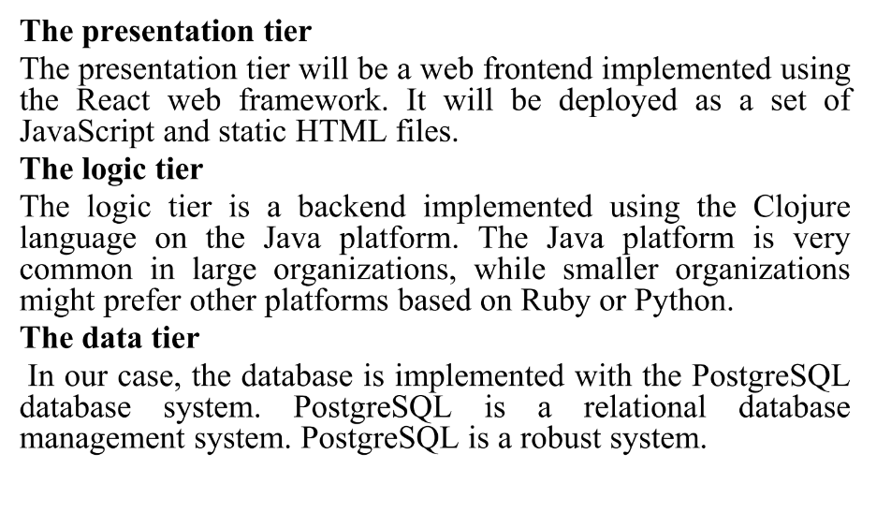

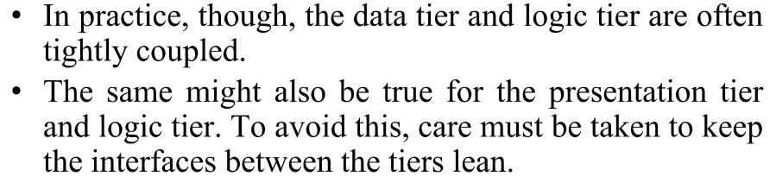d-l , p-l tightly coupled

Handling db migrations (bin,ext,db,state,vcontrol,liquibase,)
- In rdb both data and its structure are stored, making it little complex while upgrading.
- Unlike upgrading app binaries, where the app state is typically handled externally upgrading db requires consideration of the db state.
- the process of handling database migrations involves treating the database structures before and after a change as different versions.
- Version control is imp.
- using tools like Liquibase, which is a database migration system .
- automate and streamline the process of applying database changes, ensuring consistency and version control in database structures.
A binary file is a file whose content must be interpreted by a program or a hardware
processor that understands in advance exactly how it is formatted.
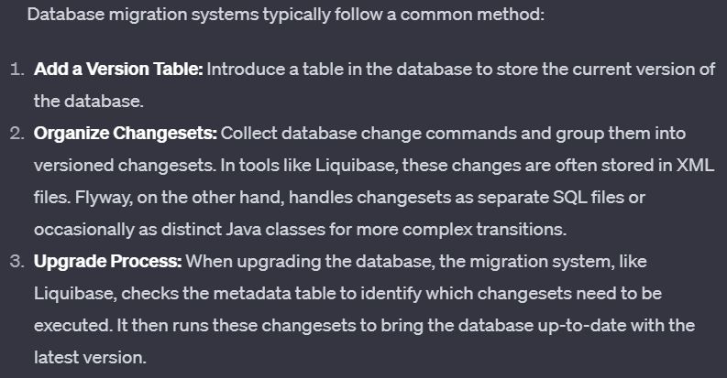

Rolling upgrades
when you don't want your end user to experience any downtime, or at least very little downtime.
example of a rolling upgrade for our organization's customer database. When we start, we have a running system with one database and two servers. We have a load balancer in front of the two servers. We are going to roll out a change to the database schema, which also affects the servers.
You start by upgrading one server at a time, allowing the other server to continue handling requests. This ensures that there is no downtime for users during the upgrade process.

Microservices
term used to describe systems where the logic tier of the three-tier pattern is composed of several smaller services that communicate with language-agnostic protocols.
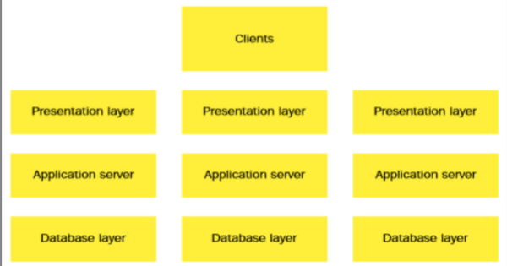
Language-agnostic protocols refer to communication standards or rules that are designed to be independent of any specific programming language. facilitate interoperability between heterogeneous systems.
architectural design pattern lends itself well to a Continuous Delivery approach easier to deploy a set of smaller standalone services than a monolith.
HTTP based, commonly JSON REST, but this is not mandatory.

DevOps, architecture, and resilience
intersection of DevOps, architecture, and resilience, particularly in the context of microservices
Challenges of Microservices:
Microservices introduce more integration points between systems, increasing the potential for failure compared to monolithic systems.
Automated testing is crucial for ensuring the quality of deployed changes but doesn't completely address the challenge of unexpected service failures.
Reseilence is recovery , ability to recover quickly and effectively from failures, disruptions, or adversities.

Resilience in Microservices Architecture:
Monitoring Strategy: (server is found to be non-functional, the load balancer is reconfigured to exclude the problematic server from the pool.)
Application-Specific Monitoring Interface
We have more running services with the microservice pattern, it is statistically more likely for a service to fail.

need for source code control
everythings code
The applications that we build
• The infrastructure that hosts our applications
• The documentation that documents our products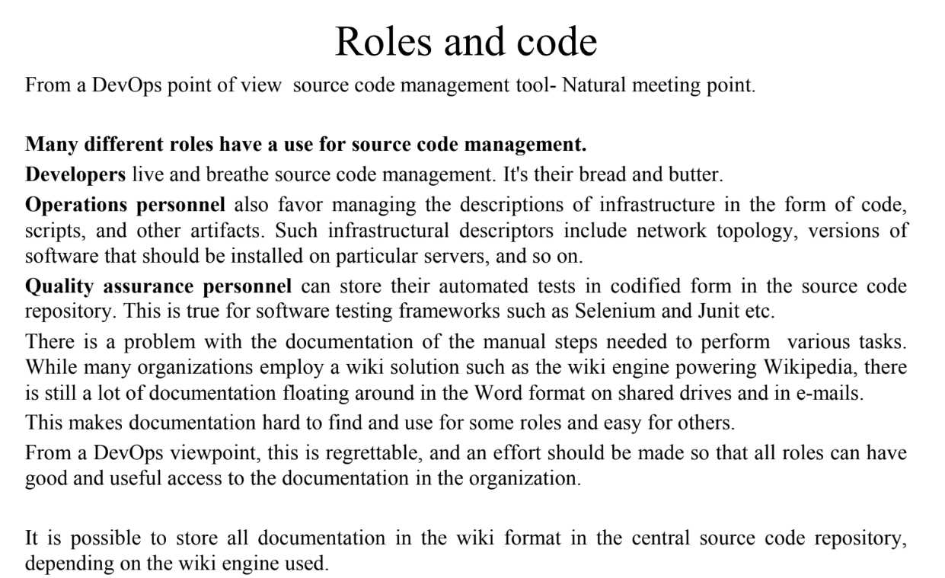

source code management system

many source code management (SCM) systems dominant is git

Unlike older version control systems that are centralized, where there is a single repository that everyone interacts with, DVCS allows every user to have their own local repository.
Dvcs benifiits
Distributed hence not connected to any nw
Therefore faster
Work pvtly until showable
several remote logins simultaneously, hence single pt failure not poss
others: bazaar, mercurial

Source code management system migrations
Save history if u can, however expensive
